**DBMS ASSIGNMENT 11**

**CLASS: TE B**

**ROLL NO: 322008**

**Problem Statement:** Implement aggregation and indexing with suitable example using MongoDB

**Screenshots:**

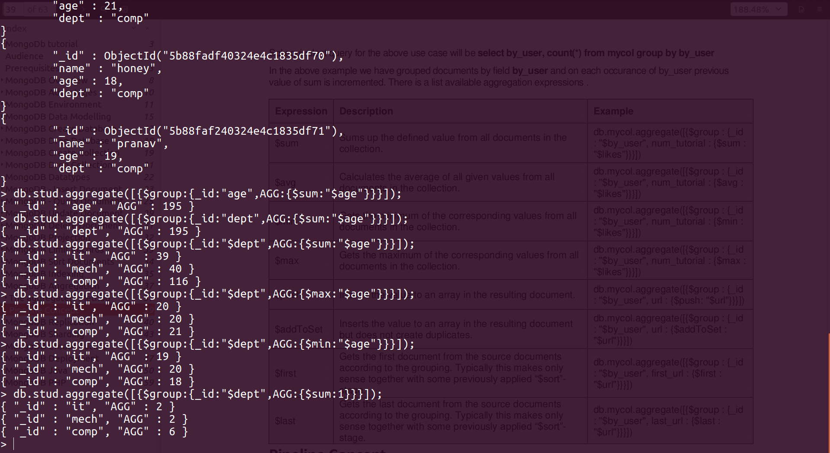

**Queries:**

Db.stud.aggrigate([{$group : {_id : “age”, AGG : {$sum : “$age”}}}]);

Db.stud.aggrigate([{$group : {_id : “dept”, AGG : {$sum : “$age”}}}]);

Db.stud.aggrigate([{$group : {_id : “$dept”, AGG : {$sum : “$age”}}}]);

Db.stud.aggrigate([{$group : {_id : “$dept”, AGG : {$max : “$age”}}}]);

Db.stud.aggrigate([{$group : {_id : “$dept”, AGG : {$min : “$age”}}}]);

Db.stud.aggrigate([{$group : {_id : “$dept”, AGG : {$sum : 1}}}]);

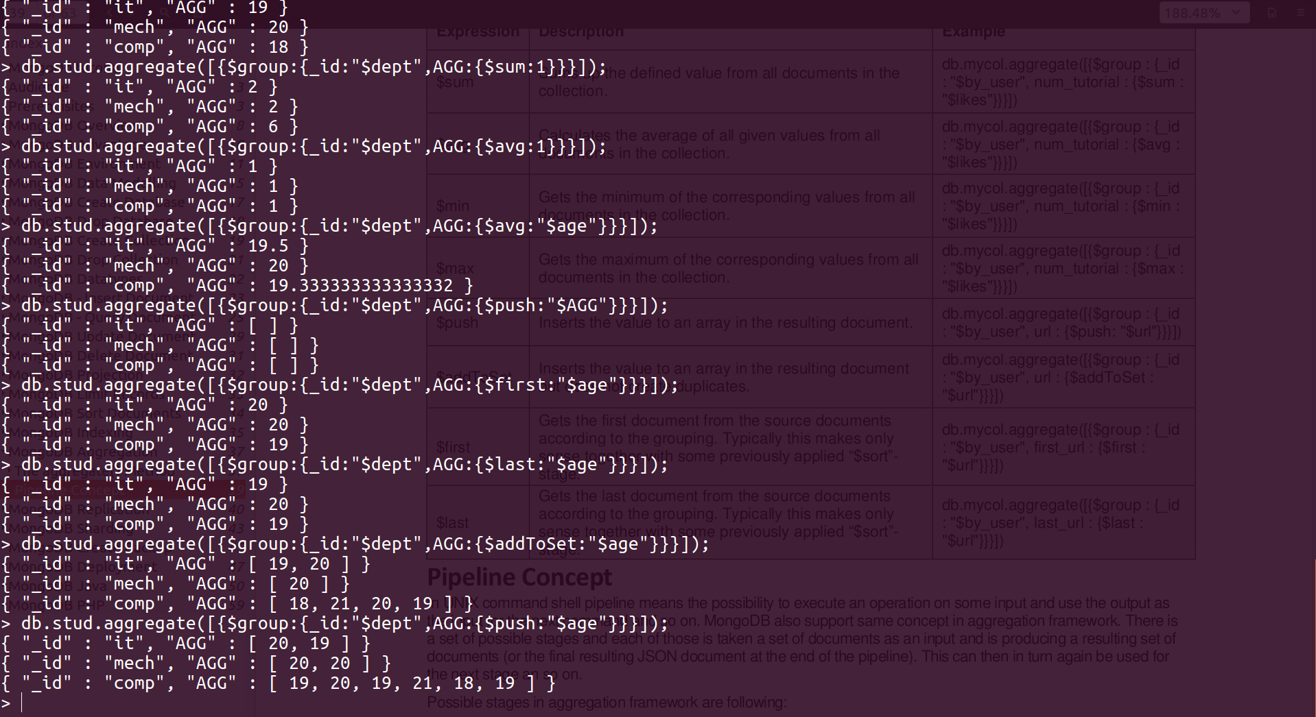

**Queries:**

Db.stud.aggrigate([{$group : {_id : “$dept”, AGG : {$avg : 1}}}]);

Db.stud.aggrigate([{$group : {_id : “$dept”, AGG : {$avg : “$age”}}}]);

Db.stud.aggrigate([{$group : {_id : “$dept”, AGG : {$push : “$AGG”}}}]);

Db.stud.aggrigate([{$group : {_id : “$dept”, AGG : {$first : “$age”}}}]);

Db.stud.aggrigate([{$group : {_id : “$dept”, AGG : {$last : “$age”}}}]);

Db.stud.aggrigate([{$group : {_id : “$dept”, AGG : {$addToSet : “$age”}}}]);

Db.stud.aggrigate([{$group : {_id : “$dept”, AGG : {$push : “$age”}}}]);

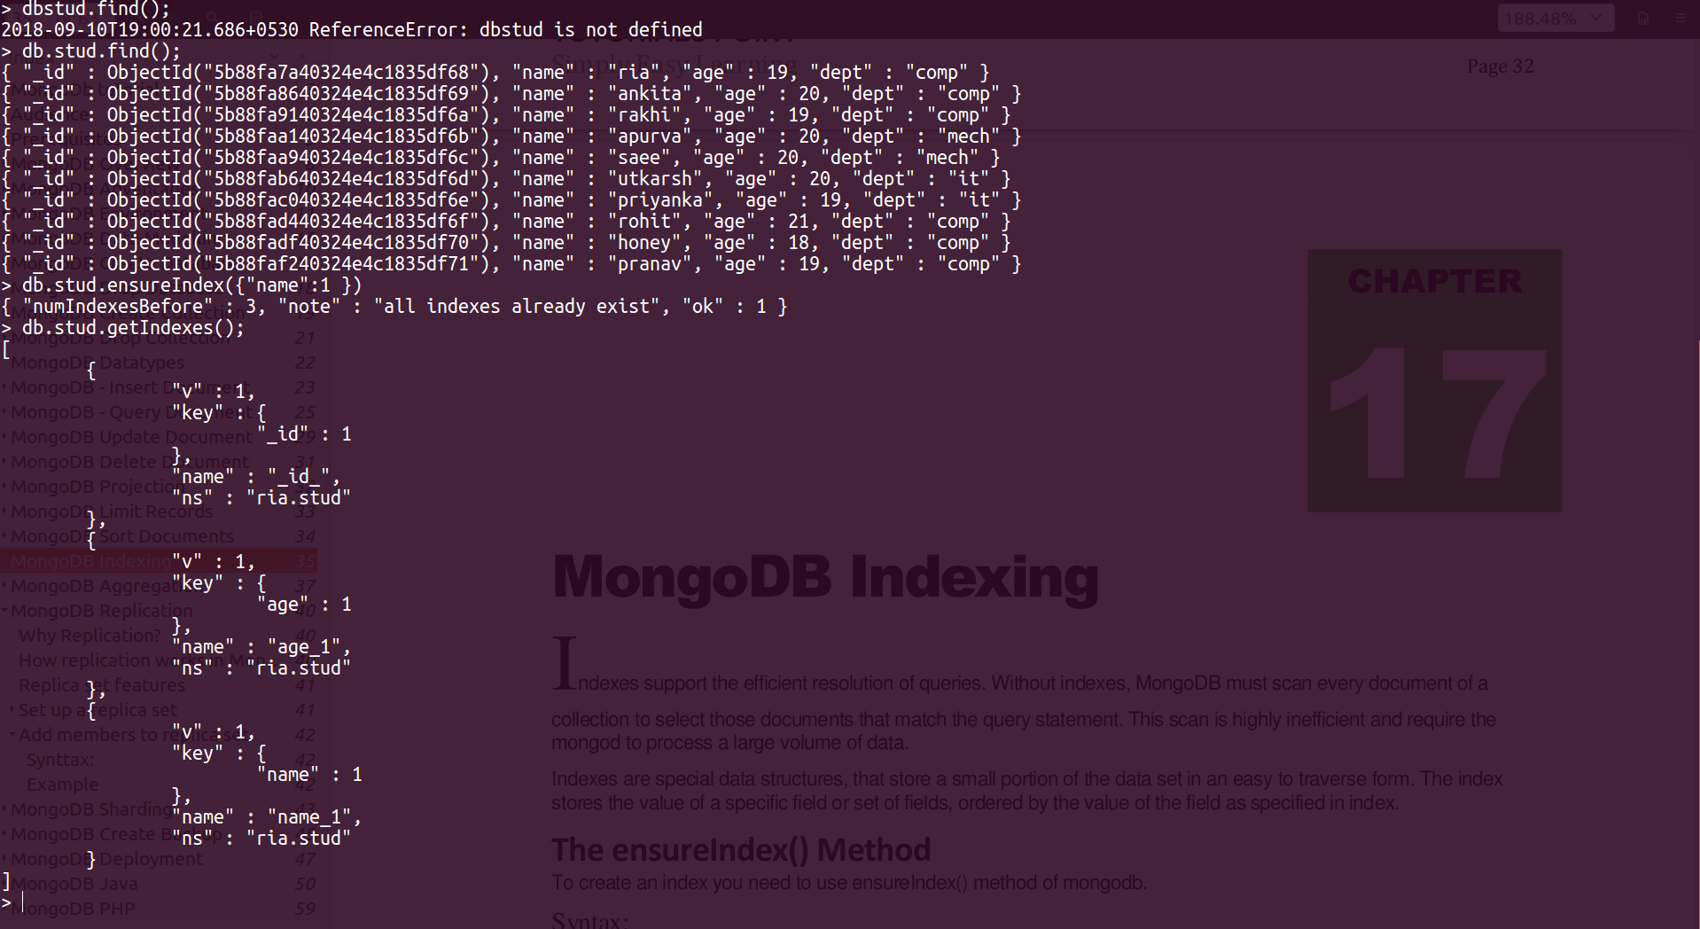

**Queries:**

db.stud.find();

db.stud.ensureIndex({name : 1});

db.std.getIndices();

**Conclusion:** Aggregation and indexing was successfully implemented in MongoDB.